NAME: RAMYA RAMESH

USN: 1BM19CS227

**PROGRAM 2 = BANKING ENTERPRISE DATABASE**

create database Banking;

use Banking;

create table Branch(branchname varchar(30),branchcity varchar(30),assests real, primary key(branchname));

desc Branch;

create table BankAccount(accno int,branchname varchar(30), balance real ,primary key (accno),foreign key (branchname) references Branch(branchname));

desc BankAccount;

create table BankCustomer(customername varchar(30),customerstreet varchar(30),customercity varchar(30),primary key(customername));

desc BankCustomer;

create table Depositor(customername varchar(30),accno int,primary key(customername,accno),foreign key(customername) references BankCustomer(customername), foreign key(accno) references BankAccount(accno));

desc Depositor;

create table Loan(loannumber int,branchname varchar(30),amount real,primary key (loannumber), foreign key (branchname) references Branch(branchname));

desc Loan;

insert into Branch values('SBI_Chamrajpet','Bangalore',50000);

insert into Branch values('SBI_ResidencyRoad','Bangalore',10000);

insert into Branch values('SBI_ShivajiRoad','Bombay',20000);

insert into Branch values('SBI_ParlimentRoad','Delhi',10000);

insert into Branch values('SBI_Jantarmantar','Delhi',20000);

commit;

select * from Branch;

insert into BankAccount values(1,'SBI_Chamrajpet',2000);

insert into BankAccount values(2,'SBI_ResidencyRoad',5000);

insert into BankAccount values(3,'SBI_ShivajiRoad',6000);

insert into BankAccount values(4,'SBI_ParlimentRoad',9000);

insert into BankAccount values(5,'SBI_Jantarmantar',8000);

insert into BankAccount values(6,'SBI_ShivajiRoad',4000);

insert into BankAccount values(8,'SBI_ResidencyRoad',4000);

insert into BankAccount values(9,'SBI_ParlimentRoad',3000);

insert into BankAccount values(10,'SBI_ResidencyRoad',5000);

insert into BankAccount values(11,'SBI_Jantarmantar',2000);

commit;

select * from BankAccount;

insert into BankCustomer values('Avinash','Bull_Temple_Road','Bangalore');

insert into BankCustomer values('Dinesh','Bannergatta_Road','Bangalore');

insert into BankCustomer values('Mohan','NationalColege_Road','Bangalore');

insert into BankCustomer values('Nikil','Akbar_Road','Delhi');

insert into BankCustomer values('Ravi','Prithviraj_Road','Delhi');

commit;

select * from BankCustomer;

insert into Depositor values('Avinash',1);

insert into Depositor values('Dinesh',2);

insert into Depositor values('Nikil',4);

insert into Depositor values('Ravi',5);

insert into Depositor values('Avinash',8);

insert into Depositor values('Nikil',9);

insert into Depositor values('Dinesh',10);

insert into Depositor values('Nikil',11);

commit;

select * from Depositor;

insert into Loan values(1,'SBI_Chamrajpet',1000);

insert into Loan values(2,'SBI_ResidencyRoad',2000);

insert into Loan values(3,'SBI_ShivajiRoad',3000);

insert into Loan values(4,'SBI_ParlimentRoad',4000);

insert into Loan values(5,'SBI_Jantarmantar',5000);

commit;

select * from Loan;

TABLES:

1. Branch

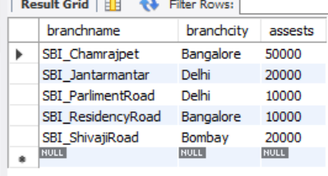

1. BankAccount

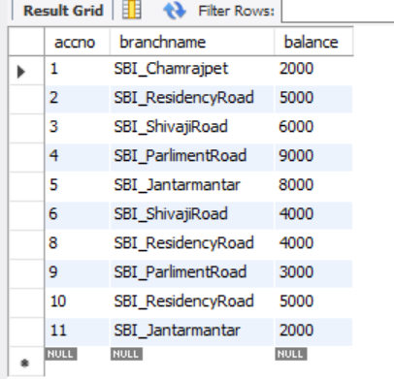

1. BankCustomer

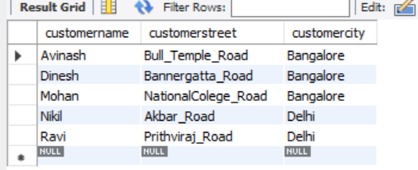

1. Depositor

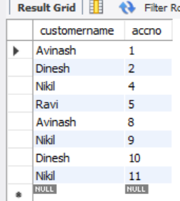

1. Loan

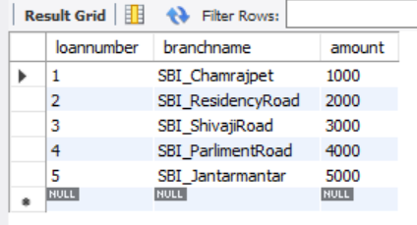

QUERIES:

1. Find all the customers who have at least two accounts at the Main branch (ex.SBI_ResidencyRoad).

select c.customername from BankCustomer c where exists(select d.customername, count(d.customername) from Depositor d,BankAccount a where d.accno=a.accno and c.customername=d.customername and a.branchname='SBI_ResidencyRoad' group by d.customername having count(d.customername)>=2);

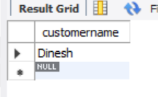

1. Find all the customers who have an account at all the branches located in a specific city (Ex. Delhi).

select d.customername from BankAccount a,Branch b,Depositor d where b.branchname=a.branchname and a.accno=d.accno and b.branchcity='Delhi' group by d.customername having count(distinct b.branchname)=(select count(branchname) from Branch where branchcity='Delhi');

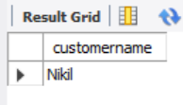

1. Demonstrate how you delete all account tuples at every branch located in a specific city (Ex. Bombay).

delete from BankAccount where branchname IN (select branchname from Branch where branchcity='Bombay');

select * from BankAccount;

